Assignment Proposal:

## Project Overview:

Brandon's Hardware Inventory Management system is a proof of concept application that is intended to be used within small businesses who need a simple and cheap way of managing inventory, taking and saving images and displaying videos for whatever purpose that they require. This project would be developed individually for different businesses depending on the needs that they require such as extra fields or a specific youtube playlist. This project will be implemented on android devices only.

## Project Purpose:

My target is for users who manage or run small businesses or are in need of a cheap inventory management system that can run on nearly any android phone making it a cheap purchase for a store without purchasing an expensive system. The best feature is the ability to easily handle a small inventory without the need for expensive software and equipment, perfect for small use cases and businesses.

## Features:

|  |  |
| --- | --- |
| Inventory Management | * Add Items To Database (Name, Brand, Stock) * Edit Items * Delete Items * View Items |
| Image Capture | * Capture Image Via Camera * Saves In Files * Saves In Gallery |
| Guide Centre | * View Videos From Youtube |

## 

## Design:

Main Menu:

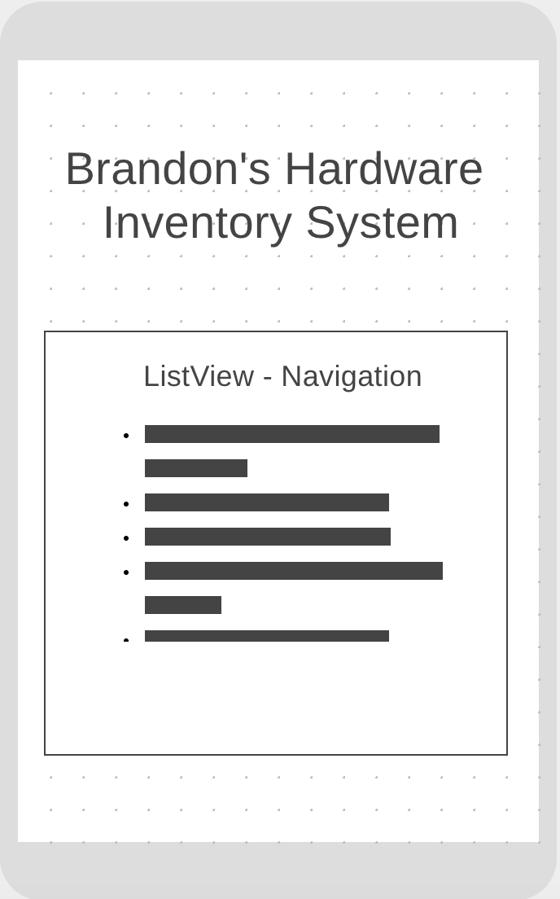

* ListView Press to Navigate to other screens

Inventory Management System:

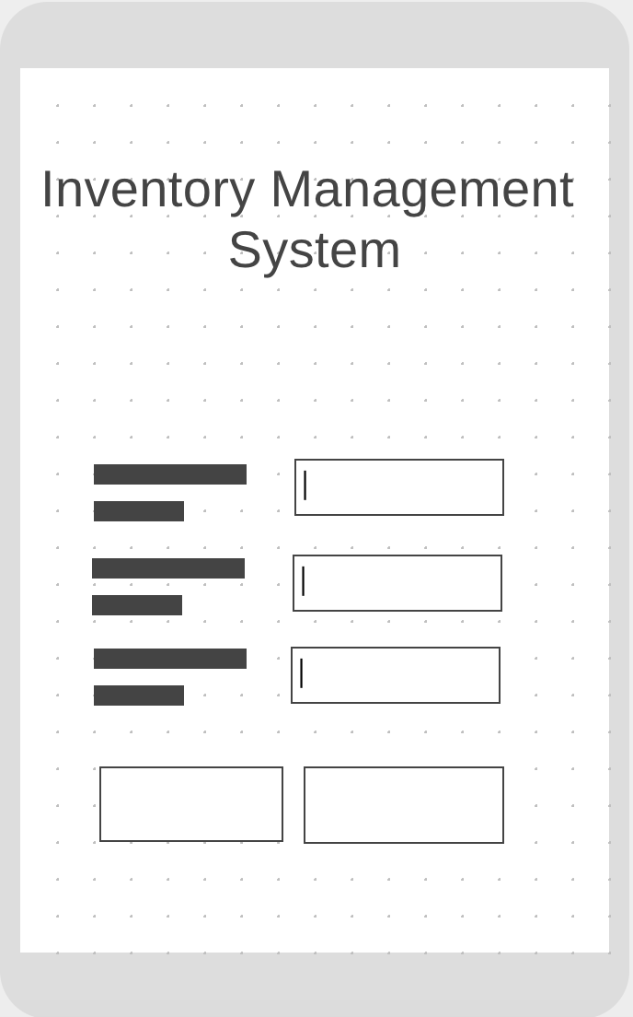

* Inputs for different values which are inputted via the keyboard on the device
* One button when pressed will insert the values into the inventory database and the other button will bring up the inventory table to view the entries.

Inventory Table:

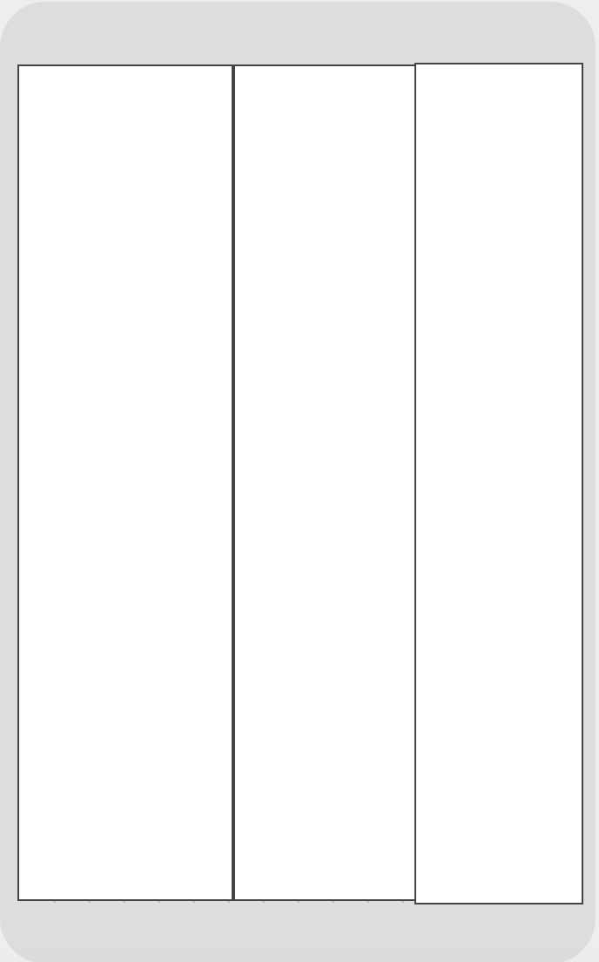

* The user will be able to scroll if there are a large amount of items within the database , if the user needs to make an edit to one entry they just need to press on the item.

Image Capture:

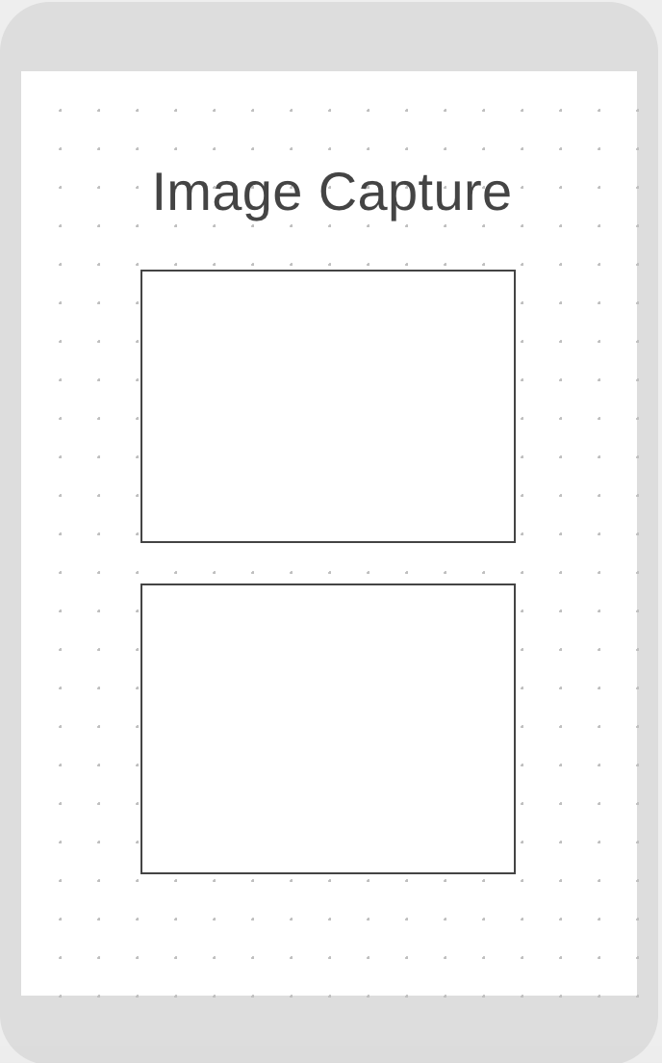

* The user will press capture to open the camera functionality which will save the image to the folder system within the device.
* The save button will save the image to the users gallery for easier access.

Guide Centre:

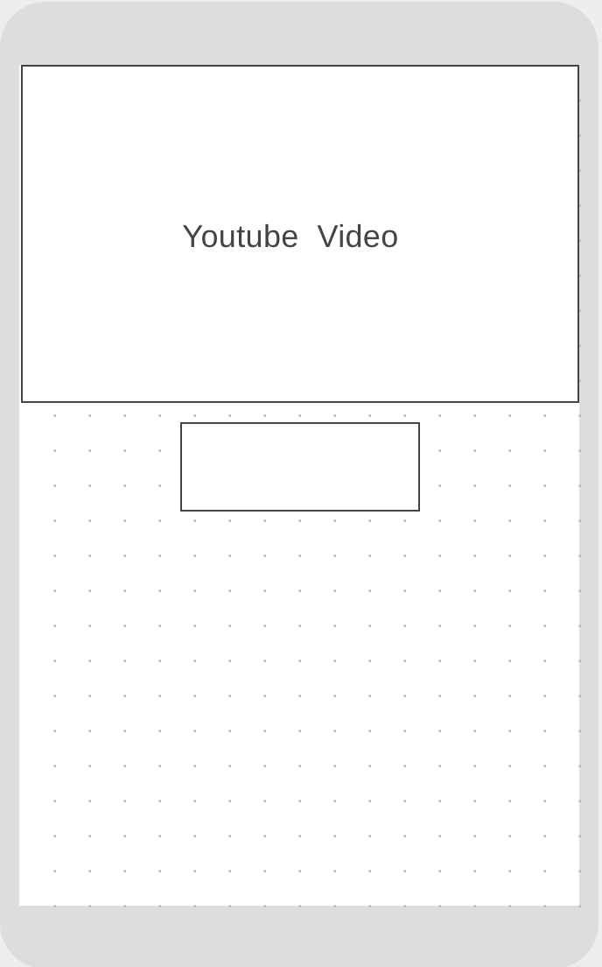

* The youtube video will play when the button is pressed.

Colour Scheme:

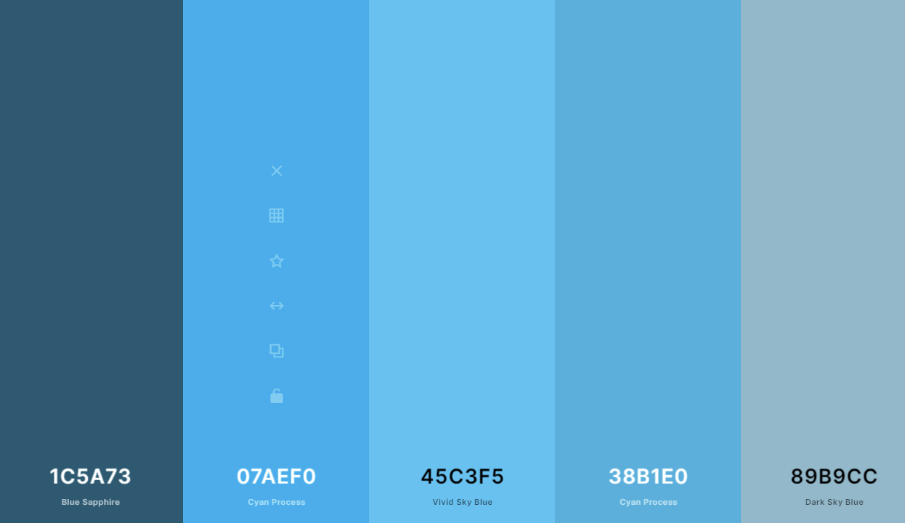

## Data:

For the requirement of holding the item information for the inventory management system the application will use SQLite which will act as the database for the users to create, edit, delete and view items.

## Class Structure:

|  |  |  |
| --- | --- | --- |
| **Name** | **Variables** | **Functions** |
| Database Helper | Database Name  Table Name  Column Names | onCreate() - Creates Table  onUpgrade() - Upgrades Table  addItem() - Add Item To Database  updateItem() - Updates item within the certain row  deleteItem() - Delete Item from certain row  getItems() - returns items to be viewed  getItemID() - returns ID for item for use in other functions |
| Item | Item Name  Item Brand  Item Stock | item() - sets item values from input  setName()  setBrand()  setStock()  getName()  getBrand()  getStock() |
| Inventory | User Interface Values | Add Item() - Runs Add Database Helper function. |
| Edit Item | Item Detail Values  User Interface Values | buttonEdit Click - Will run Database Helper Update Item.  buttonDelete Click - Will run Database Helper Function. |
| ViewListItem | Results - Gets Items  Item  itemLists  List View | populateList() - Populates the list to be viewed within the application. |
| itemListViewAdapter | customLayout  Items  viewID | getView() - sets the layout for the custom view for the list. |
| imageCapture | imageToUploadUri  File | takePicture() - Takes a picture and saves it to internal storage.  saveToGallery() - Saves file to Gallery |